ASSIGNMENT QUESTIONS ON DIGITAL MARKETING

DIGITAL MARKETING ASSIGNMENT

JAYA SHAKTHI ENGINEERING COLLEGE

AMERTHYASEN. P ( B27F OE F A7486B94BB 9C 436C 6 DF 472466 )

1. Create a blog or website using Blogspot and WordPress.

Customize the theme design and post new article with 500

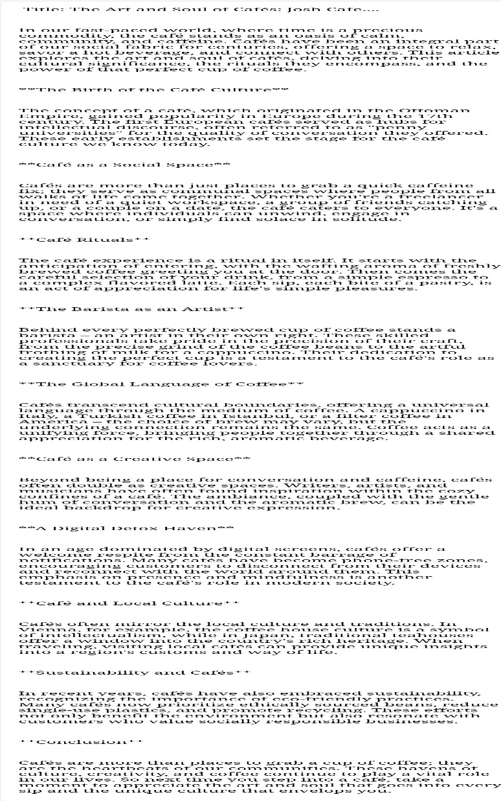 Words.

[https://joshcafe1222.blogspot.com/2023/10/josh-cafe-article.html](josh)

1. Create a New Facebook Business Page and post one

Social media poster for your brand.

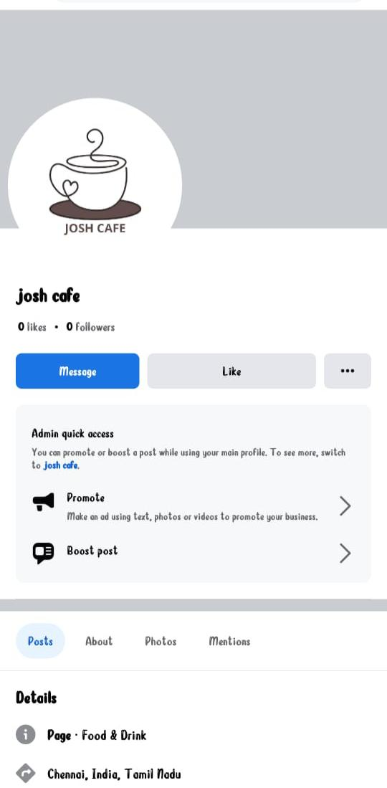<https://www.facebook.com/profile.php?id=61552502669951&mibextid=ZbWKwL>

1. Create and design a social media advertisement poster

Using canva.



[https://m.facebook.com/story.php?story_fbid=122098595318083422&substory_index=178160458669647&id=61552502669951&mibextid=Nif5oz](josh)

1. Create email newsletter design using MailChimp or canva

Tool.

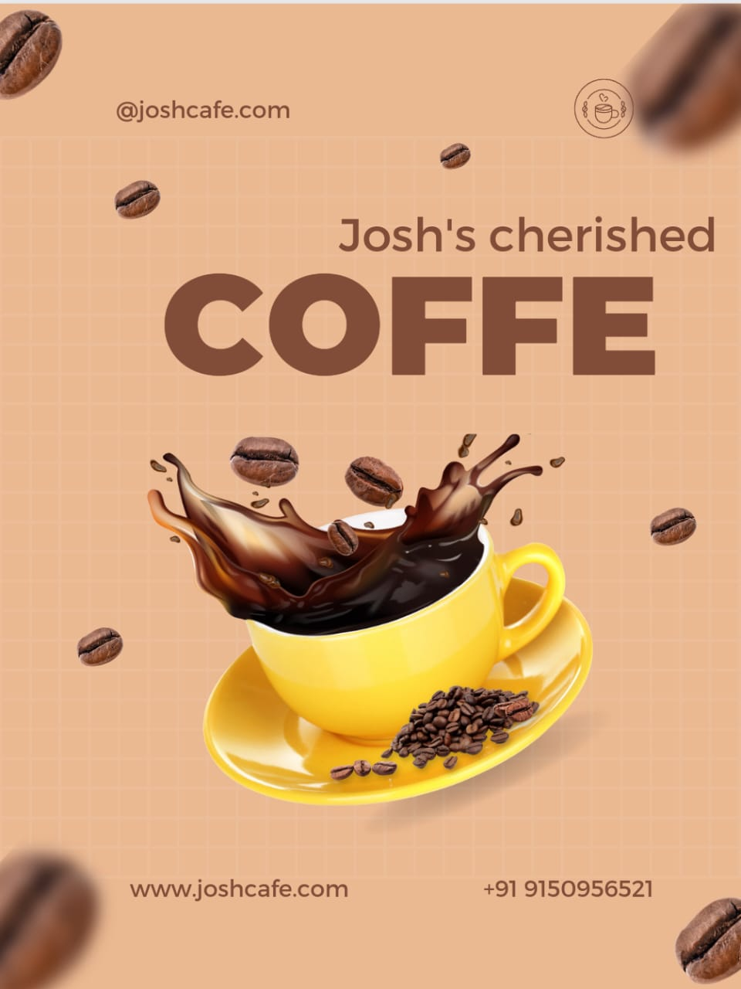<https://joshcafe1222.blogspot.com/2023/10/josh-cafe-news-letter.html>